**UNIVERSITY INSTITUTE OF ENGINEERING AND TECHNOLOGY**

**MAHRSHI DAYANAD UNIVERSITY**

**ROHTAK**

**Integration Of Two Renewable Resources**

**(Solar And Wind Energy) For A Sustainable Future**

**Presenter's Name :- Under the supervision :–**

Prince Nayan Dr. Ravinder Kumar Sahdev

Kishan Gupta Ms. Manisha

Shubhi Saraswat

Himanshi Hooda

Chandramani Prasad Singh

Manita

**AGENDA**

* **INTRODUCTION TO SOLAR AND WIND ENERGY**
* **ADVANTAGES AND CHALLENGES OF EACH**
* **INTEGRATION OF SOLAR AND WIND ENERGY**
* **BENEFITS OF INTEGRATION**
* **CASE STUDIES**
* **CONCLUSION AND FUTURE PROSPECTS**
* **INTRODUCTION TO SOLAR TRACKERS**
* **TYPES OF SOLAR TRACKERS**
* **HOW SOLAR TRACKERS WORK**
* **BENEFITS AND ADVANTAGES**
* **APPLICATIONS**
* **CASE STUDIES**
* **CONCLUSION**
* **INTRODUCTION OF ARDUINO UNO**
* **ADVANTAGES OF ARDUINO**
* **THE SERVO MOTOR**

**INTRODUCTION TO SOLAR ENERGY**

1. Solar energy harnesses the power of the sun through photovoltaic panels.
2. Clean, renewable, and abundant source of energy.
3. Provides electricity for homes, businesses, and utilities.
4. High efficiency.
5. Continuous power supply.

**ADVANTAGES OF SOLAR ENERGY**

1. Low environmental impact
2. Scalability
3. Minimal maintenance
4. On-site generation

**CHALLENGES OF SOLAR ENERGY**

1. Intermittent energy production
2. Weather-dependent
3. Land and space requirements

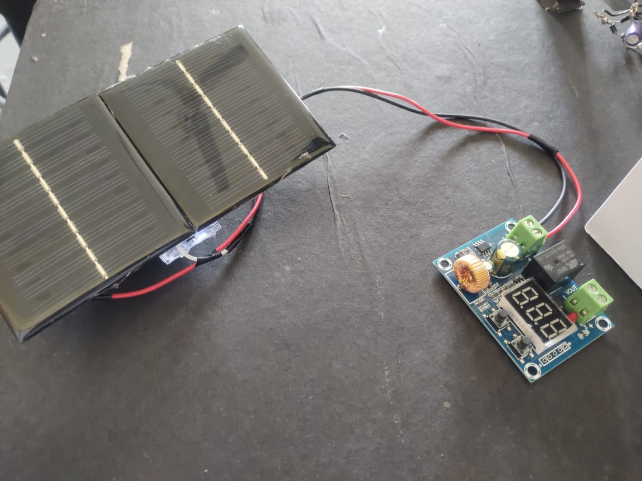

**INTRODUCTION TO WIND ENERGY**

1. Wind energy captures the kinetic energy of moving air using wind turbines.
2. Another clean and renewable source of power.
3. Widely used in both onshore and offshore applications.

**ADVANTAGES OF WIND ENERGY**

1. High energy output
2. Consistent resource (in windy areas)
3. Reduces greenhouse gas emissions
4. Potential for offshore installations

**CHALLENGES OF WIND ENERGY**

1. Intermittent wind patterns
2. 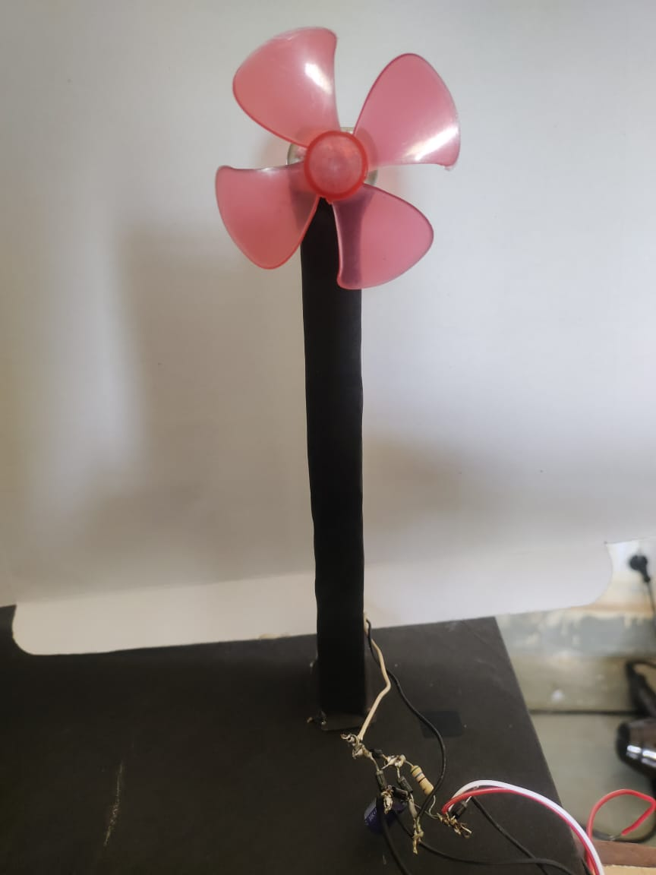Noise and visual impact
3. Bird and bat collisions
4. Initial high installation costs

**INTEGRATION OF SOLAR AND WIND ENERGY**

1. Combining both resources to create a more reliable and consistent energy source.
2. Complementary characteristics:
3. Solar peaks during the day.
4. Wind can be strong at night or during cloudy periods.

**BENEFITS OF INTEGRATION**

1. Improved reliability: A more consistent power supply.
2. Higher energy output: Reduced intermittency.
3. Efficient use of resources: Maximizes land and infrastructure.
4. Grid stability: Smoother power generation.
5. Reduced energy storage needs: Less reliance on batteries.

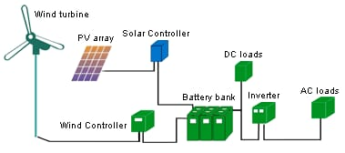

**CASE STUDIES**

Share examples of successful solar-wind integration projects:

1. The Redstone Solar Thermal and Wind Project in South Africa.
2. The Hybrid Renewable Energy Park in India.
3. The Hornsdale Power Reserve in Australia.

**CONCLUSION AND FUTURE PROSPECTS**

1. Recap the advantages of solar and wind energy integration.
2. Emphasize its role in a sustainable energy future.
3. Discuss ongoing research and potential advancements.
4. Encourage continued investment and development in this field.

**INTRODUCTION TO SOLAR TRACKERS**

1. **Solar trackers are devices that orient solar panels or mirrors toward the sun.**
2. **They follow the sun's path, optimizing energy capture throughout the day.**
3. **Commonly used in photovoltaic and concentrated solar power systems.**

**TYPES OF SOLAR TRACKERS**

**Single-Axis Trackers:**

1. **Follow the sun's movement along one axis (usually east-west).**
2. **Horizontal and tilted designs.**
3. **Dual-Axis Trackers:**

**Track the sun along two axes (azimuth and elevation).**

1. **Precise orientation for maximum energy capture.**

**Concentrated Solar Power (CSP) Trackers:**

1. **Used in solar thermal power plants.**
2. **Direct sunlight to a central receiver or heat transfer fluid.**

**HOW SOLAR TRACKERS WORK**

1. **Sensors detect the sun's position.**
2. **Motors or actuators adjust the orientation of solar panels or mirrors.**
3. **Control systems ensure panels are perpendicular to incoming sunlight.**

**BENEFITS AND ADVANTAGES**

1. **Increased Energy Yield:**

**Up to 40% more energy production compared to fixed panels.**

1. **Higher Efficiency:**

**Maximizes the "capture window" for sunlight.**

1. **Reduced Land Footprint:**

**Requires less space for the same energy output.**

1. **Improved Grid Integration:**

**Smoother power generation with reduced fluctuations.**

1. **Longer Panel Lifespan:**

**Minimized thermal stress on panels due to reduced heat.**

**APPLICATIONS**

* **Utility-Scale Solar Farms:**
* **Large-scale power generation.**
* **Maximizes return on investment.**
* **Commercial and Industrial Installations:**
* **Energy cost reduction for businesses.**
* **Residential Solar Systems:**
* **Enhanced self-sufficiency for homeowners.**
* **Concentrated Solar Power (CSP) Plants:**
* **Generates high-temperature steam for electricity production.**

**CASE STUDIES**

* + - **Highlight successful solar tracker installations:**
* **The Alamosa Solar Generating Project in Colorado.**
* **The Cerro Dominador CSP Plant in Chile.**
* **Residential installations with tracking systems.**

**CONCLUSION**

1. **Recap the benefits of solar tracker technology.**
2. **Emphasize its role in improving solar energy efficiency.**
3. 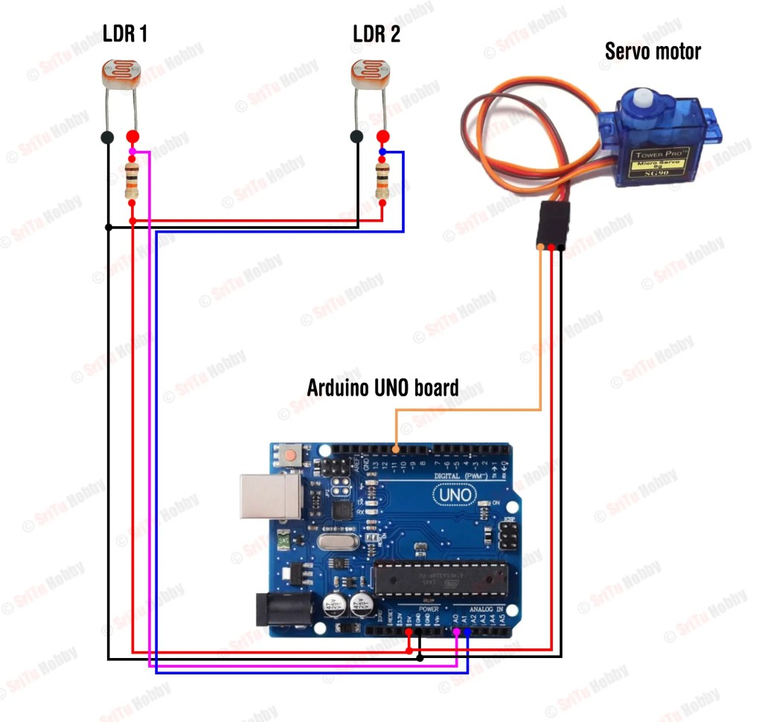**Encourage its adoption in renewable energy projects.**

**INTRODUCTION OF ARDUINO UNO**

The **Arduino Uno** is an [open-source](https://en.wikipedia.org/wiki/Open-source) [microcontroller board](https://en.wikipedia.org/wiki/Microcontroller_board) based on the [Microchip](https://en.wikipedia.org/wiki/Microchip_Technology) [ATmega328P](https://en.wikipedia.org/wiki/ATmega328P) microcontroller and developed by [Arduino.cc](https://en.wikipedia.org/wiki/Arduino). The board is equipped with sets of digital and analog [input/output](https://en.wikipedia.org/wiki/Input/output) (I/O) pins that may be interfaced to various [expansion boards](https://en.wikipedia.org/wiki/Expansion_board) (shields) and other circuits. The board has 14 digital I/O pins (six capable of [PWM](https://en.wikipedia.org/wiki/Pulse-width_modulation) output), 6 analog I/O pins, and is programmable with the [Arduino IDE](https://en.wikipedia.org/wiki/Arduino#Software) (Integrated Development Environment), via a type B [USB cable](https://en.wikipedia.org/wiki/USB_cable). It can be powered by the USB cable or by an external [9-volt battery](https://en.wikipedia.org/wiki/9-volt_battery), though it accepts voltages between 7 and 20 volts. It is similar to the [Arduino Nano](https://en.wikipedia.org/wiki/Arduino_Nano) and Leonardo. The hardware reference design is distributed under a [Creative Commons](https://en.wikipedia.org/wiki/Creative_Commons) Attribution Share-Alike 2.5 license and is available on the Arduino website. Layout and production files for some versions of the hardware are also available.

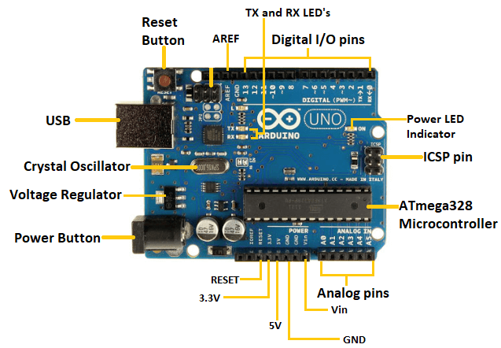

**ADVANTAGES OF ARDUINO**

* **Simplicity**

Arduino's paintings are designed to suit the needs of all engineers, designers, professors, students, and interactive electronics enthusiasts around the world.

* **The price**

The Arduino Plate is less expensive than any competitor of the same type. The most expensive painting is not more than $ 50.

* **Self-Assembly**

Easy to deal with and easy to connect circuits, as we mentioned in our first article that it was an easy solution to the problem of microcontrollers and complex connections.

* **Multi-platform**

The Arduino program has the ability to work with all the different operating systems of Windows, Mac and Linux, while most other boards running on Windows only

* **Easy and simple software environment**

The "Environment" programming environment is designed to be easy for beginners and powerful professionals and its programming language "Arduino C" is easy to learn

**THE SERVO MOTOR**

* The servo engine is a motor that comes with a Gear gearbox and a Shaft transmission that gives motion greater torque and greater precision. This engine can rotate 180 degrees and in some types 360 degrees.
* The servomotor is internally made up of a "mostly microcontroller" control circuit. When the engine gives pulses at a certain time constant, the engine rotates to the angle according to that time constant.
* In each type, the time constant varies from one engine to another according to the manufacturer and the technical bullet in that comes with the servo engine.
* In the Arduino, programming environment there is a library called Servo Library installed in the program. This library gives us the ability to control most of the 180degree Cervo drives. At the end of this post, you will have the ability to use the library's commands through practical examples.

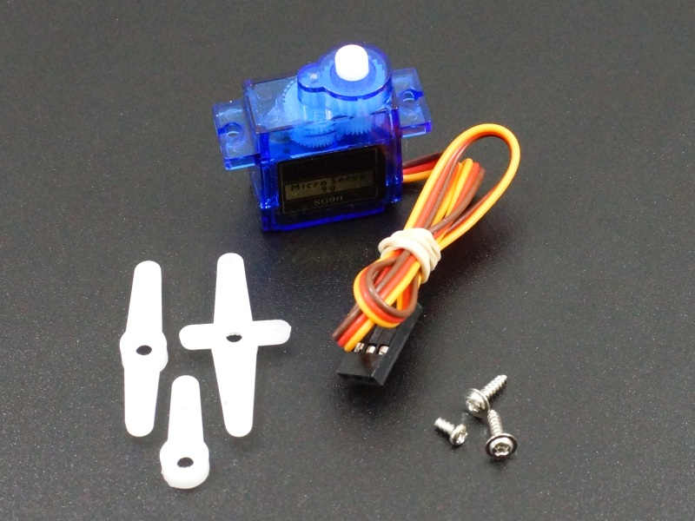

**Fig:** Mini Servo Motor

**THANK YOU**